Year 7: Term 3: The Church

Lessons | Title and learning Objective | Tasks | Place a ‘X’ in the box when completed.
One | Jesus bids farewell  L.O: To know that Jesus gave his mission, power and authority to the apostles. To reflect on what this means for us. | Complete Gap fill on the beginning of the Church, using keywords.  Write a diary entry on how you would have felt when Jesus ascended.  S+C - Explain why Jesus stayed on earth for 40 days after his resurrection?
Two | Peter is Chosen  L.O:To know that Jesus gave his mission, power and authority to the apostles. To reflect on what this means for us. | List three ways that you can be tested in life - think about school, home, community.  Read through John. 21:15-17 - Who is Jesus referring to as the sheep, lamb, and what is Jesus asking Simon Peter to do?  S+C - Why did Jesus ask Peter the same question three times?  Why was Peter Chosen as the leader?  What does the Church mean to you?  What does the Church mean to the community? (Think about what the Church does to support families and individuals, how has the Church supported you?
Three | Lesson 3: Pentecost  L.O: To understand how the Church began. To think about the message it has for us. | Recap on previous lesson; why did Jesus stay on earth for 40 days?  Write the meaning to the key words in the table.  Read the passage and list 5 adjectives.  Describe the meaning of tongues of fire.  Explain why the gift of speech is important to the disciples.  Recap on the meaning of ‘Repent’  Draw, pain, create a collage on the Pentecost.
Four | Birth of the Church  L.O: To understand how the Church began. To think about the message it has for us. | Write the meaning of the key words in the table.  Read through the passage and summarise it in five bullet points.  S+C - What does the bread symbolise?  Who was the twelfth apostle?  True or False, read through the meaning of apostle, put a ‘X’ in the correct box.  Read through Acts 3:1-7, how does the ‘lame man’ illustrate that God works through the apostles.  S+C - Is there a time that God has worked through you, or through someone else?
Five | Drama unfolds  L.O: To be aware of some of the challenges the first Christians encountered. To reflect on the challenges we face as Christians. | Read through the passage, who do you think He is?  Think back to a previous lesson, when did Jesus warn about his followered being persecuted?  What does resurrection mean?  Watch: https://www.youtube.com/watch?v=bE8O7Qfbw_I  Read through the Stoning of Stephen, what would you have done if you were in the same situation.  Watch: https://www.youtube.com/watch?v=_u9eN72iFjo, what does Martyr mean?  Create a comic strip on the story of Stepehn.
Six | Saul’ Experience  L.O: To be aware of the challenges the first Christians encountered. To reflect on the challenges we face as Christians. | Read through the story of Saul.  What lesson did Jesus teach Sual on the road to Dimascos?  How does this lesson apply to us today?  Create a logo to help remember this lesson, uploading it to google classrooms?
Seven | Quick Quiz  L.O: To reflect on key words and key information | Answer a range of questions that reflect on previous lessons.

Lesson 1:
Jesus bids farewell
L.O: To know that Jesus gave his mission, power and authority to the apostles. To reflect on what this means for us.

Lesson one:
Complete the gap fill. Use the words in the box on the next page.

(Type your answer into the correct place, make sure that you type in Green so that I can see clearly your answers)

For _________days after rising from the dead, Jesus stayed on earth and frequently came to see his chosen ____________ to prepare them for the time to come when he would no longer be with them.

One _____________, the disciples were in the Upper Room with the door locked because they feared the _________. “Jesus came and stood among them and said to them, ‘___________ be with you.’ When he said this, he showed them his hands and his side. The disciples were glad when they saw the _________. Jesus said to them again, ‘Peace be with you. As the __________ has sent me, even so I send you.’ And when he had said this, he breathed on them, and said to them, ‘Receive the ____________ _____________. If you forgive the sins of any, they are forgiven: If you retain the sins of any, they are retained”
John, 20:19-23
Jews Father Peace
Holy Spirit forty
Disciples evening Lord

Write a Diary entry as if you were present when Jesus ascended to heaven.
What was happening? How would you feel? What task did Jesus ask of you?
(Type your diary entry into the box on the next page, remember you need to be typing in green so that I can see clearly your answers: You can edit it and type away)

Ascension - the return of Jesus to his father in heaven, forty days after his resurrection from death.

Stretch and challenge:
Explain why Jesus stayed for forty days after his death?
(Type your answer here in green)

Lesson two:

Peter is chosen.
L.O: To know that Jesus gave his mission, power and authority to the apostles. To reflect on what this means for us.

Jesus wanted his eleven disciples to be his representatives on earth. He wanted them to form a community with Peter as the leader, but before saying this to Peter, he tested him to see if he was ready!
Jesus said to Peter,
“Simon, son of John, do you love me more than these others do?”
Peter replied, “Lord, you know I love you.”
Jesus said, “Feed my lambs.”
Again, Jesus said,
“Simon, son of John, do you love me?”
“Yes, Lord, you know I love you,” said Peter.
Jesus said, “Tend my sheep.”
And again, Jesus said,
“Simon, son of John, do you love me?”
Peter was upset that he asked him a third time and said,
“Lord, you know everything; you know I love you.”
Jesus said, “Feed my sheep”
John. 21:15-17

List three ways that you can be tested.
1.
2.
3.

Answer the questions in the boxes. To type your answers into the boxes, you will need to edit the boxes, double clicking each one.
Who do you think the lambs represent?

Who do you think the sheep represent?

What was Jesus asking Simon Peter to do?

Stretch and challenge:
Explain why Jesus asked Peter the same question three times?
(Type your answer in green here)

But why Peter? There were 11 disciples that Jesus wanted to be representatives on earth… Why Peter as leader?

So… On an earlier occasion, when Jesus had asked his disciples who they thought he was, it was Peter who spoke up and said , “You are the Christ, the Son of the living God.” (This was before anyone knew who Jesus was)...Jesus knew that it was God who had revealed this to him.
Disciple means to be a learner or follower.

Why choose Peter as the leader?
(Type your answer in green here)

Rewrite this passage, what is Jesus saying to Peter and his chosen disciples?

“Go therefore, make disciples of all nations, baptise them in the name of the Father and the Son and of the Holy Spirit, and teach them to observe all the commands I give you. And know that I am with you always; yes to the end of time.”
Matthew. 28:18-20

(Type answer in green here)

What does the Church mean to you?
(Type your answer in green here)

Explain the meaning and importance of the Church to the community?
(Type your answer in green here)

Lesson 3: Pentecost
L.O: To understand how the Church began. To think about the message it has for us.

Scattered... Shattered... Amazed... Astonished...

Within a period of fifty days, the disciples had seen their Lord and Master crucified, they had fled in fear for their own lives and had just lost all hope when they witnessed the risen Jesus ALIVE and with them. They had experienced a whirlwind of astonishing events, one after another and even saw him ascend to heaven. Now they were on their own again.

Remember - Jesus stayed with the disciples for forty days before he ascended…

Why did Jesus stay with his disciples for forty days? Explain your answer in green here…

Recap on keywords:
What do these keywords mean?
Complete the table below in green.

Key word | Meaning
Disciple
Crucifixion
Ascension
Resurrection

So, what happened after fifty days?
As instructed by Jesus, the disciples went to the Upper Room in Jerusalem to wait for the Holy Spirit. They were fearful so they locked the door. They remembered Jesus dying on the cross and were afraid they would end up like him. But when Pentecost day came round the disciples felt…

How do you think the disciples felt?
Use five adjectives that can explain how they would have felt.
1.
2.
3.
4.
5.

“Suddenly they heard what sounded like a powerful wind from heaven, the noise of which filled the entire house in which they were sitting and something appeared to them that seemed like tongues of fire; these separated and came to rest on the head of each of them. They were all filled with the Holy Spirit, and began to speak foreign languages as the Spirit gave them all gift of speech”
Acts 2: 1-4
What does ‘Tongues of fire mean’?
(Answer in green)

Why is the gift of speech, speaking in foreign language important?
(Answer in green)

At the time, there were many people in Jerusalem who came from other countries for the Jewish feast of Pentecost which was held every year in memory of the giving of the Law of the Old Testament to Moses. On receiving the Holy Spirit, the apostles came running out into the streets and began to speak about Jesus. All the foreigners were astonished that they understood them in their own languages. Of course, there were some sceptics around who said, “Take no notice, these men are drunk” (Acts 2:13)

Peter went on to preach the Good News boldly and confidently. He reminded the people of the miracles, wonders and signs which God worked through Jesus and then confronted them with the stark facts.

“This Jesus … you crucified and killed ...But God raised him up”

“Repent and be baptised every one of you in the name of Jesus Christ for the forgiveness of your sins; and you shall receive the gift of the Holy Spirit” (Acts 2:23,38)

Pentecost is a Jewish feast day that is celebrated 50 days after passover
Passover is the a Jewish festival that celebrates the freedom of the Jews from Slavery in Egypt.

Baptism is the rite of sacrament of initiation into the Christian Church

What does repent mean?
(Answer below in green)

Research a variety of illustrations of Pentecost and reflect on them.
Create a collage/ picture/ painting of Pentecost.
Take a photo and upload it to google classroom.

Lesson four:
Birth of the Church
L.O: To understand how the Church began. To think about the message it has for us.
Complete the table below in green:
Keyword | Meaning
Ascension
Disciple
Crucifixion
Resurrection
Baptism
Passover
Pentecost
Repent

The outpour of the Holy Spirit on the apostles at Pentecost marked the birth of the Church. The twelve apostles were the first members of the Church because they had been the companions of Jesus. They heard all his teachings. They were witnesses of his miracles and his resurrection. Matthias was chosen to fill the place of Judas. Peter, as head of this Christian community, made decisions and led the Church with the help of the other apostles. They would often meet together to pray, break bread and study.
All that saw them would be filled with awe, and they all knew that God was with them.
Summarise the events in the passage above in 5 bullet points:

Stretch and Challenge:
What does the bread represent?

Who was the twelfth apostle?

True or False?
Put a Cross X in the correct box.
Apostle means to follow to learn
Apostle means ‘one sent out’ to preach the word of God

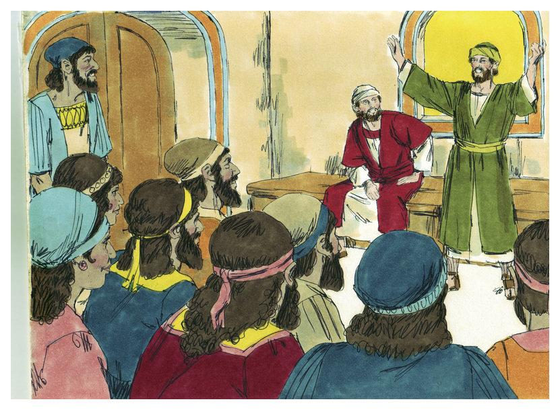

Read through the passage below:
One day, when Peter and John were going to the temple at the hour of prayer a man who was lame from birth looked at Peter and John expecting to get some money. Peter placed in his hands, not coins, but a new life from God.

First, the man clasps Peter’s hand. Then, he is pulled shakily to his feet. Next, he takes a few wobbly steps. Finally, he runs and jumps up and down like an excited child praising God. He cannot contain himself. No longer is he condemned to sit and beg.

The lame man ends by thanking God for refusing him what he fervently prayed for and ginving him something far greater. The power that was Jesus was now present and active in his apostles. They had inherited the mission and the authority of Jesus. On the first day, there were over 3000 people who were baptised, and the Lord added to the number day by day those being saved.
Even those who were opposed to the apostles could not deny what was happening and wondered what could be done to get rid of them - within days, numbers had grown to 5000.
Acts 3:1-7 adapted.
God works through the apostles. Explain how the account of the man that was lame illustrates this?
(Answer in green below)
Stretch and challenge: Try to think of an example from your own life or of someone else’s

Lesson five:
Drama unfolds
L.O: To be aware of some of the challenges the first Christians encountered. To reflect on the challenges we face as Christians.

Before returning to his Father in heaven. Jesus had warned the apostles that they would be brought before the governors and kings to be tried as enemies for doing God’s work. They must expect to be imprisoned, beaten and even killed, but just the same, the work would go on and nothing would stop it. He would be with them, even to the end of the world.

Who is He in the passage above?
Write your answer here in green:

Can you think of a time that Jesus warned his disciples and followers on how they may be treated?
Answer in green here:

If the world hates you, remember that it hated me before you.
John. 15:18
In the world you will have trouble but be brave: I have conquered the world.
John. 16:33
If they persecuted me, they will persecute you too…
John. 15:20
I have told you all this so that your faith may not be shaken.
John 16:1
I will see you again and your hearts will be full of joy no one will take from you.
John 15:22

The apostles remembered that Jesus had forewarned them - but they had no idea how quickly events would unfold. Things worked out exactly as Jesus had warned them in the long farewell talk, he had with them at the Last Supper (John’s Gospel, chapters 13-17). Filled with the Holy Spirit, Peter and the other apostles preached openly and confidently about the Resurrection of Jesus. They worked many miracles among the people, who flocked to listen to them.

What does Resurrection mean?
(Answer here in green) …

“So many signs and wonders were worked by the apostles that the sick were even taken out into the streets and laid on beds and sleeping-mats in the hope that at least the shadow of Peter might fall across some of them as he went past”
Acts 5:15

The excitement that was generated from the people becoming cured was exactly what the Jewish authority feared. The high priest was jealous , With the backing of the Sadducees they had the apostles put in prison. God was with the apostles. “At night, an angel of the Lord opened the prison gates and said as he led them out, ‘Go and stand in the Temple, and tell all the people about the new Life’ (Acts 5:19-21)

Sadducees were a group of Jews that denied Jesus resurrection and any existence of spirits.

Watch the clip of the Angel freeing the apostles.
https://www.youtube.com/watch?v=bE8O7Qfbw_I

Stoning of Stephen
As the number of disciples steadily increased, the apostles elected Stephen, a man of great faith, to help them. Stephen was filled with grace and power and began to work miracles and great signs among the people.

Before long, he was arrested and brought before the Sanhedrin, the high council. In a powerful speech he showed how the Old Testament prophecies had been fulfilled in Jesus.

He ended by attacking the emptiness of the Temple worship and the blindness of the religious authorities of Jerusalem:
“You stubborn people, with your pagan hearts and pagan ears. You are always resisting the Holy Spirit, just as your ancestors used to do”
Acts 7:51
The members of the council were raging and took what he said as blasphemy. They dragged him outside the city and stoned him. Stephen was praying all the time and when the great stones began to strike him. Stephen was praying all the time and when the great stones began to strike him, he went on his knees and cried aloud, “Lord, do not count this sin against them!”
Blasphemy means false speech about holy things, e.g swearing or cursing

Stephen was on his own, no one had taken his side. He could have apologised and taken back what he had said.

What would you have done if you were in the same situation and why?
Answer in green here

Watch the clip below:
https://www.youtube.com/watch?v=_u9eN72iFjo
What does ‘Martyr’ mean?

Create a comic strip on the story of Stephen.
Take a photo and upload to classrooms.
An onlooker named Saul approved of the murder. But God had other plans for him!

Lesson 6:
Saul’s Experience
L.O: To be aware of the challenges the first Christians encountered. To reflect on the challenges we face as Christians.

Saul planned to go on persecuting the Christians until there were none left anywhere. He heard there were many in Damascus, a city about 150 miles from Jerusalem. He sat out on his journey determined that no one should stand in his way. Just before he reached the city, suddenly and without warning, a great light, much stronger than the sun, shone around him. He fell down on the ground and heard a voice say, “Saul, Saul, why do you persecute me?”
“Who are you, Lord?” he asked, and the voice answered, “I am Jesus, and you are persecuting me, get up and go into the city and you will be told what you have to do.” Saul was soon to understand that persecuting the Christians was the same as persecuting Jesus.

Persecution means hostility and ill-treatment because of religious beliefs.

Saul experienced a deep conversation. (You can read about it in Acts 9:1-19). He began to preach for and not against Jesus. He showed the Jews that Jesus was really risen from the dead and had sent his Spirit to be with all who believed in him. No matter what happened he wouldn’t stop preaching; his arguments were convincing, and everyone was listening to him. At last, the Jewish authorities could bear it no longer, so they made a plot to kill him. News of it reached Saul.

Damascus was a city with high walls. The gates were guarded day and night, but when it was dark the disciples took Saul and let him down from the top of the wall, lowering him in a basket (Acts 9:20-25). It was around this time that Saul's name was changed to Paul.
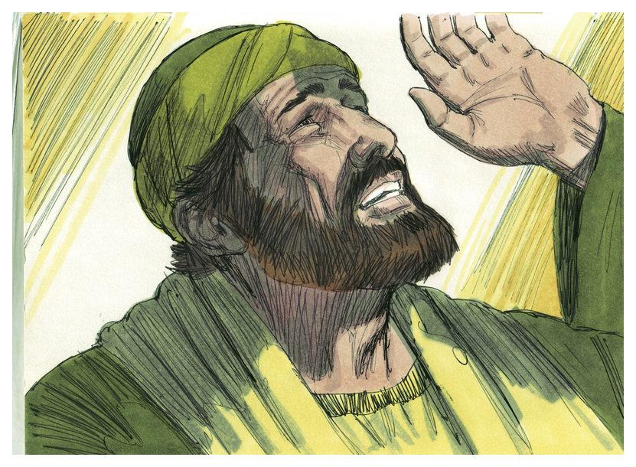
What lesson did Jesus teach Saul on the road to Damascus?
Answer in green here
How does that lesson apply to us today?
Answer in green here
Design a logo to help you remember this lesson.
Upload a photo of your logo.

Lesson seven:
Quick Quiz
L.O: To reflect on key words and key information.

- Highlight the correct key word to the definition. (1 mark)
To be a follower and a learner is a …
Apostle Disciple Blasphemy Pentecost

- Outline three teachings that Jesus said may happen to the disciples and his followers from following him. (3 marks)

- Explain the importance of Baptism to Christian faith. (4 marks)

- Explain the importance of the gift of speaking in foreign languages to the apostles. Refer to a biblical quote (5 marks)

- “The Church is the most important part of being a Christian” Evaluate this statement. In your answer you need to write a two-sided argument and reach a Justified Conclusion. Use references in your answers to support your answer. (8 marks)

Some people may agree with this statement because ….
This means…
Evidence of this can be seen …

However, some people may disagree with this statement because …
This means …
Evidence of this can be seen …

To conclude… I believe… the reason for this is …

Mark out of 21.

