WJEC GCSE Sociology
Research methods booklet (Ms Ledwith)

Name: _____________________________________________
Tutor group: _____________________________

Contents and homework check list
# | Title | Homework# | - / x (completed)
1 | Introduction to social research methods
2 | Quantitative and qualitative data | Exam question 1
3 | Questionnaires / activity | Exam questions 2&3
4 | Observations and data
5 | Ethics | Exam questions 4
6 | Data gathering and sampling
7 | Stages of research | miscellaneous
8 | Evaluating observations
9 | Evaluating questionnaires | Homework question 6
10 | Evaluating interviews
11 | Choosing a method | Questionnaire activity
12 | Primary and secondary data | RP
13 | Research project | RP
14 | Research project | Research project / revision
15 | Assessment

Introduction to sociological research methods 1.
Key terms | Definitions | Examples
Primary research |  | Interviews and research carried out by sociologists to families. They are the first to do the research
Secondary research |  | Sociologist uses statistics from sociological reports or journal articles
Participant |  | Women in focus groups who have been beaten by men / students in a sixth form college
Sample |  | 50 sixteen year olds from Brockenhurst College
Hypothesis |  | I predict that more people will be able to recall information in silence than in a loud condition
Data |  | Numbers, words, colours
Pilot study |  | An investigation into reading time took place before the main project began
Quantitative data |  | Numbers like a Likert scale
Qualitative data |  | How are you feeling today?
Triangulation |  | Becker used statistics to back up his observations
Observation |  | When Zimbardo conducted his Stanford prison experiment he was also one of the participants so he could see everything that was going on

Qualitative and quantitative data 2.

Have a look at this questionnaire. Is it qualitative or quantitative? Give your reasons why.
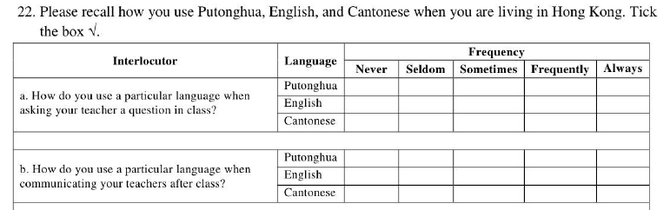
Reasons for your answer:

Now have a look at this one.

- How do you feel about sixth form psychology at college?
- I see, so you have said that you would benefit from the structured environment of school as opposed to college. What else can you tell me about this?

Reasons for your answer:

Now or a tricky one! Write underneath this whether this is qualitative or quantitative (nb it uses closed questions which are yes/no)
- Do you like chocolate? yes / no
- Do you like swimming? Yes / no

Qualitative data is sometimes called ___________________________________ because it relies on human opinion rather than scientific fact. It can be very useful when you are trying to gather________________ human data from a relatively small sample. However if you had a large sample of, say 300 people, it would be very difficult and __________________ consuming. In this case you would use ___________________________ data. In this case it would be better because both in analysis and data collection you can identify ________________ or patterns in data.
Rich / time/ quantitative / subjective / trends

Difference between data collection and data analysis
Data is the information that you collect like _____________ data. It can be collected in interviews, focus groups or even observations. This type of data is _______________ because it is data that is collected there and then and no one else has collected it. Data can also come from surveys, which is ____________________ data. It can be from articles which can be either _____________________ or _____________________ data, information from a survey which is _________________________.
The data collection techniques you use, such as __________________________, ___________________________, _______________________, affect how you are going to analyse the data.
Qualitative, interviews, primary, numerical, Raw, observations, secondary, quantitative, Likert

DATA ANALYSIS:
Descriptive statistics are:
1.
2.
3.
They often give us an idea of an overall trend and they help us to see patterns in data like the average IQ score in a class. However they can’t explain outliers – in this case, parametric tests should be used.
Descriptive statistics only work with data which is ____________________________.

Go onto BBC bitesize maths and see if you can practice some maths where you work out the mean average.

Thematic analysis is: _____________________________________________________________________________________________________________________________________________________________________________________________________________________________________________________________________________________________
This is commonly used by sociologists because they are interested in gathering rich human data that needs to become objective so that it can be scientific. Thematic analysis uses qualitative information.

Questionnaires 3.
QUALITATIVE
Fill in the gaps using the words in the box underneath the text. Once you have done this you can start to design your own questionnaires using guidance from the lesson and you can make sure you include these key words.

There are different ways a ________________________ can be answered. __________-__________ is when a participant fills it out on their own and then sends it back to the researcher. Questionnaires can also be carried out face to face where the researcher asks questions. When the researcher asks a participant a wide range of questions that are led by the participant this is called an _________________________________ questionnaire and when they have a list of questions they want to ask this is called a __________________ _________________ questionnaire. A preferred feminist methodology is the use of ________________________ groups which is when the researcher goes to the participants’ community (i.e. field research) and holds a group where participants can say what they feel and how they think change might happen.

Focus groups / semi-structured / questionnaire / unstructured / self-report

Quantitative questionnaires
Quantitative questionnaires are different to qualitative because they are made up of _____________________________. This is an advantage because it means ____________ in _______________can easily be identified. Examples of quantitative ____________________ are __________________ scales which are similar to _______________ questionnaires. These involve assigning a __________________ to a statement such as “I love dogs” circle 1 being most true and 5 being least true. These questionnaires are particularly useful when you have a large __________________ and don’t have time or resources to interview everyone.

Numbers / value / likert / trends / sample / matrix / data / questionnaire

Observations

Observation is literally watching a group that you are researching. There are two types of observation:
1.

2.

Name one advantage for each of these and one disadvantage for each.

Observation is used so that researchers can gather information about their participants and look at their natural behaviour, often in their natural environment.
To make things scientific and logical and able to be analysed, observation schedules can be used which turn qualitative data into quantitative data. We call logical, scientific data _________________________________.
This is the opposite to human opinion which is called _______________________-- and isn’t always reliable because human opinion can be influenced by so many things.
Examples of observation schedules are:

Ethics
DC COWPAD

Deception
C
Consent
O
W
Protection
A
D

Before you conduct any research it is essential that you make sure your participants have signed a letter of informed consent and that you have gone through DC COWPAD. Sometimes this means the research project can be tricky. You must also only work with people over the age of 16.

Data gathering and sampling
Before gathering data and your sample you need to write a hypothesis. A hypothesis gives a prediction with something that you intend to change. For example:
H1 (Alternative / experimental hypothesis): “There will be a significant increase in the number of words recalled in 2 minutes if words are read in silence”
Here, the things that are changing are reading words in silence rather than loud. Also, you must use the null which says there won’t be a difference:
H0 (null hypothesis): “There will be no significance increase in the number of words recalled in 2 minutes if words are read in silence”

Sampling is the people you gather your data from and the way you are going to gather them. For example, snowball, event, opportunity, volunteer etc.
It affects the research because, for example, if someone is volunteering or being paid to participate, they are only going to be from a small group of people, not the whole population, and they are more than likely going to want to please the experimenter.
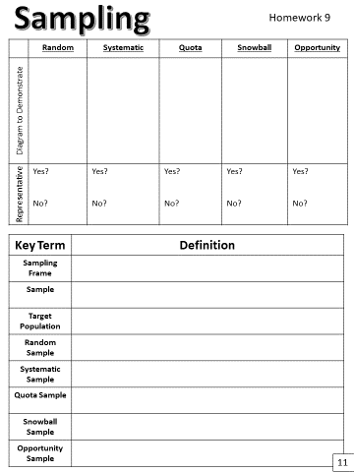

Evaluating questionnaires
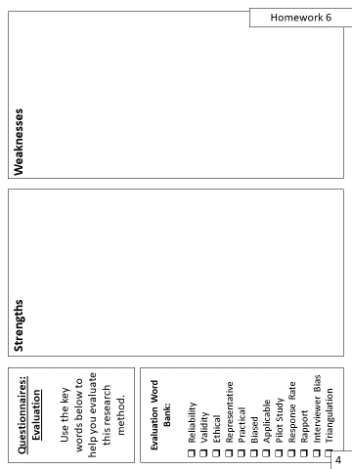

Activity
Thinking about some of the topic areas we have covered (i.e. crime and deviance , family, culture etc) think about some information that you would really like to find out about. Pretend you were actually there at the scene of a crime, or that you are part of a particular nuclear or non-nuclear family unit.

- Write a statement that you would like to find out
- Write out a semi-structured questionnaire
- Write out a structured (yes/no) or likert questionnaire
- Write a suitable conclusion justifying your use of each questionnaire to investigate what you wanted to investigate

Research project
Now that you have gained an understanding of sociological research, it’s time for you to run your own project and you will have a few lessons to do this. You will not be conducting this research in actuality, because you are under the age of sixteen as are the majority of potential participants – this would break ethical codes of conduct. But you can make up this research. In the first research project lesson you will need to come up with a sociological research aim, an alternative hypothesis and a null hypothesis and your proposed sample. You will also need to provide a very short literature review. Use the boxes provided to help you. In the second of the research project lessons you will need to write your method (whether qualitative or quantitative) and examples of the questions you will use. In your third lesson you will make up the results and analyse them, justifying your reasons for analysis.

Lesson 1:
Aim:

Sample:

H1:

H0:

Lesson 2:
Mini Literature review

Method:

Lesson 3:
Results (these should be put into a table, whether using quantitative or qualitative research. Use the space below to draw your data table.

Now analyse your data in a couple of sentences: _________________________________________________________________________________________________________________________________________________________________________________________________________________________________________________________________________________________________________________________________________________________________________________________________________________________________________________________________________________________________________________________________________________________________________________________________________________________
