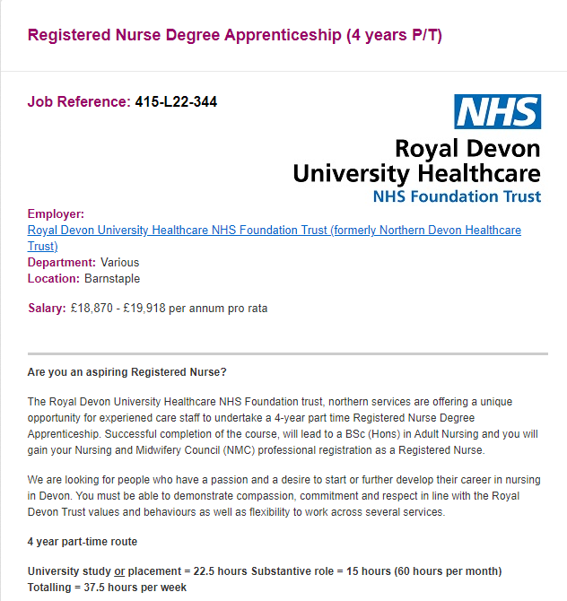
JOB DESCRIPTION

- Job Details
Job Title: Registered Nurse Degree Apprenticeship (RNDA) 4-year part time route.

Reports to: Practice Education team / Department Manager/ Ward

Job Summary
Are you an aspiring Registered Nurse?

The Royal Devon University Healthcare NHS Foundation trust, are offering a unique opportunity for Experienced care staff to undertake a 4-year part time Registered Nurse Degree Apprenticeship. Successful completion of the course, will lead to a BSc (Hons) in Adult Nursing and you will gain your Nursing and Midwifery Council (NMC) professional registration as a Registered Nurse.
We are looking for people who have a passion and a desire to start or further develop their career in nursing in Devon.

As a Registered Nurse Degree Apprentice, you will attend dedicated learning blocks of theory study time with a local University which will be delivered either on their University campus or via webinar sessions. You will also attend practice placement blocks at the North Devon District Hospital as your host trust and sponsors. (22.5 hours per week on set days).
As a Registered Nurse Degree Apprentice, you will work part-time in your substantive role (15 hours per week, opposite your dedicated theory study time/practice placement days).
Whilst you will be allocated to one specific area to work clinically each week, you will experience working across both internal and external placements to gain an appreciation of the different areas of local healthcare service and meet the Nursing and Midwifery Council (NMC) requirements.

University study or placement = 22.5 hours
Current substantive role = 15 hours (60 hours per month) Totalling = 37.5 hours per week

Key Principal Duties and Responsibilities

- Deliver high quality, compassionate care under the direction of a Registered Nurse (or other care professional dependent on setting) with a focus on promoting health and independence.
- Work as part of a designated clinical team delivering care that focuses on the direct needs of the individual.
- Carry out specific delegated clinical and care tasks and responsibilities to a high standard and competency, under the direction and supervision of a registered nurse or other registered allied healthcare professionals.
- Work with a practice supervisor/assessor to take responsibility for developing own clinical competence, leadership and reflective practice skills within the workplace, whilst on placements and throughout university study.
- Develop and improve practical and theoretical knowledge, competence and skills throughout the Registered Nurse Degree Apprenticeship, gathering and maintaining all evidence and feedback as required in line with the NMC and apprenticeship standards.
- By the end of the Registered Nurse Degree Apprenticeship, demonstrate the ability to work independently, with minimal supervision, assessing and delivering care, within your limitations until you have obtained your professional registration.
- Assist in the implementation of appropriate action to meet the specific physical, emotional and psychological, social, cultural and spiritual needs of individuals, service users and carers.
- Communication is vital with both employers and the education provider. Attend regular reviews with the University and Employer to monitor clinical and academic progress. Non-attendance at these reviews can breech apprenticeship obligations and can result in removal from the course and role.

We are committed to equal opportunity for all in recruiting and supporting a diverse workforce and welcome applications from all sections of the community, regardless of age, disability, gender, race, religion, sexual orientation, maternity/pregnancy, marriage/civil partnership or transgender status. We expect all staff to behave in a way which recognises and respects this diversity, in line with the appropriate standards.

This post has been identified as involving access to vulnerable adults and/or children and in line with Trust policy successful applicants will be required to undertake a Disclosure & Barring Service Disclosure Check.

PERSON SPECIFICATION | ESSENTIAL | DESIRABLE
EDUCATION AND QUALIFICATIONS
Minimum entry requirements of GCSEs grade C/4 or above in Maths, and English or equivalent functional skills may be considered. | x
Plus one of the following Level 3 qualifications below:-  - UCAS tariff: 104 - 120 UCAS points from a minimum of two A levels (excluding General Studies).  - Access Course: Passed a named Access to Higher Education Diploma with at least 45 credits at Level 3, 33 at merit/distinction which must include 15 Level 3 credits in Science/Social Science/Psychology/Sociology.  - BTEC National Diploma  - International Baccalaureate: 28 points overall to include a minimum of two higher level at 4 (preferably from Biology/Human Biology/Applied Science). If overseas and have not studied English within IB - Must have IELTS: 7.0 overall with 7.0 in all elements | x

SKILLS, KNOWLEDGE AND ABILITIES
Insight into roles responsibilities of post including academic commitment | x
Role modelling good behaviour | x
Ability to communicate clearly and effectively in English in both verbal and written formats with patients, relatives and carers and all members of the multi-disciplinary team | x
Ability to deal with non-routine and unpredictable nature of the workload and individual patient contact | x
Computer literate with applications such as /Microsoft office including email and My Care | x
Able to support and reassure patients/carers in distress | x
Ability to develop effective and appropriate relations with people, their families, carers and colleagues | x
EXPERIENCE
Relevant work or volunteering experience |  | x

