

In your April Connect...
We have lots of updates to tell you about this month!
A Message from the Team - Where we are this month
First Look Virtual Event
On-Campus Visit Days
Meet-the-Russell-Group Webinars - Spring Series - Last Chance to Book!
Shakespeare Shake-Up Day is back for a second year!
Art and Design Experience Day
History Study Day
Ignite Your Journey Programme
"Levelling Up" - Online Tutoring and Mentoring Scheme
Help us with our Research in Black Holes and the Aurora
Online Masterclass for A-Level Physics Students
UniFrog - Business Webinar
Biomedical Engineering / Electronics & Computer Science Taster Course
Biomedical & Medical Engineering Webinar - Watch the Recording
Textile Design collaborative projects with Occupational Therapy
Change people’s lives with a Career in Nursing
*NEW* BA Language, Culture and Communication
School of Engineering Design Show
Open Day Dates for 2024
Widening Participation Travel Bursary
Sanctuary Scholarships
Get a Prospectus



First Look Virtual Event
Do you want to know more about the University of Southampton before coming to an Open Day? Get a taste of student life at our First Look virtual event on Wednesday 8 May, from 16:00 – 20:00.
Join live sessions to learn about student life, and get your questions answered by current students and staff:
+ Explore your new home: cities, campuses, sport, Students’ Union and more!
+ Make your application stand out from the crowd
+ Money matters: from rent to food, we've got you covered
+ Explore your future career: careers and employability and student enterprise
+ Student life and support: your well-being, study abroad and more
+ Learn about accommodation, your home away from home
+ Applying for a visa
After the event, we’ll send you recordings of all the sessions, so don’t worry if you're interested in two sessions running at the same time.
Book Now

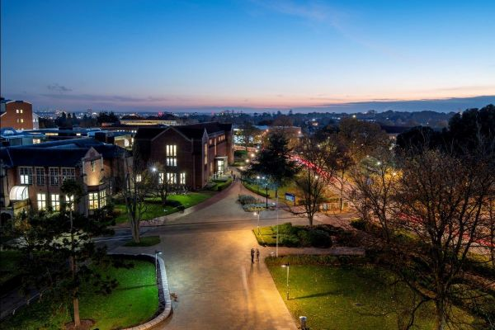

Bookings open for on-campus visit days
Bookings remain open for our on-campus visit days for schools and colleges. The days are aimed at groups of Year 12 students and are designed to offer pupils an insight into studying at university, both generally as well as specifically at Southampton.
Each day will run between 10am and 2pm. They will include:
- a talk on the University of Southampton and applying to universities
- a student Q&A with current student ambassadors
- a campus tour
- a taster lecture delivered by one of our academics
To book, follow the links below:
18 June Visit Day - Book Now
19 June Visit Day - Book Now
27 June Visit Day - Book Now
28 June Visit Day - Book Now
1 July Visit Day - Book Now
2 July Visit Day - Book Now



Meet the Russell Group Webinars - Spring Series
Last Chance to Book!
Taking place from the 30th April to the 2nd May, we have five 90-minute sessions each featuring expert panelists who will offer clear, impartial guidance for students looking at taking the next step in their educational journey.
Covering topics from What is the Russell Group & Why Study There, Student Life, and Personal Statements & How to Apply, each session will have presenters from various RG institutions, including The University of Southampton.
Please do share with your students and encourage them to join for valuable information in researching choices and decision making.
Book Now



Shakespeare Shake-Up Day - It's Back!
14th June 10:00 - 14:00
Our popular Shakespeare Shake-Up Day returns to our Avenue Campus for a second year. Open to Years 10 - 13, the day is a unique opportunity to enrich your GCSE and A-Level English courses with insights provided by Shakespeare experts. The day includes a taster lecture and two interactive workshops, helping you discover new details about Shakespeare's world and his writing.
We welcome school/college groups as well as individual bookings. To book your place, click the button below.
Book Now

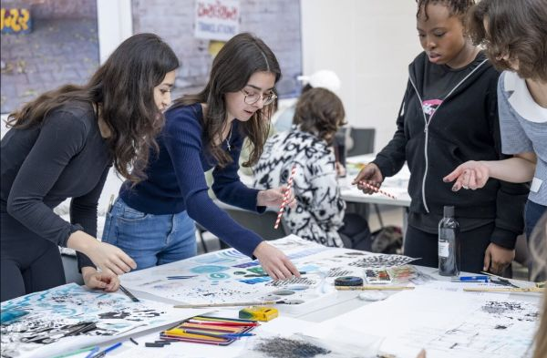

Art and Design Experience Day
16th July 10:00 - 14:30
Join us at Winchester School of Art for this hands-on day to explore our creative, art and design subjects! In this interactive event, you'll delve into our programmes through practical sessions on one of two pathways: Fine Art, Fashion Design and Textile Design; or Graphic Communication, Creative Computing, and Games Design & Art.
We welcome bookings from Year 12 School and College groups, as well as individual Y12 students. Click below to book your place!
Book Now



Early Modern and Modern History Study Day
Monday 17th June - 09:30 - 14:45
Featuring talks from experts in the field, this event will tackle topics that both cover or complement popular A level History modules, and showcase something of the sheer range of subjects available to those studying History at Southampton.
We will cover both British history (including lectures on 'The Prayer Book Rebellion of 1549' and 'The British Empire in the Modern World'), and non-British history (including lectures on the USA's Manhattan Project and the Cold War, and on 'The Russian Revolution: Hopes, Fears, Tragedy').
There will also be a session with some of our current brilliant students, involving a Q&A and the opportunity for attendees to ask current students about life and studying at university.
More Info & Book



Ignite your Journey Programme 2025
Details Launching Soon!
Applications open in May for students currently in Year 12 for our Ignite your Journey programme.
Part of our flagship widening participation activity, Ignite your Journey is designed to support university applications, help develop the skills needed for study at a research-led university and support the transition to higher education.
The programme includes an online learning module, virtual Q&As, on-campus activities and e-mentoring with a current University of Southampton student.
Details about the programme and eligibility criteria can be found below:
More Information

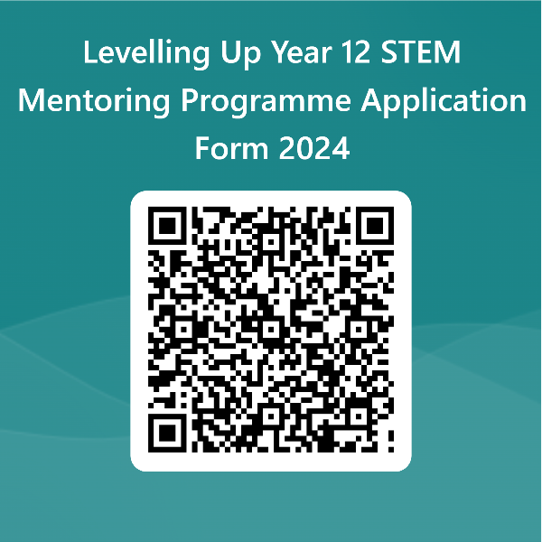

Applications are open for the Levelling-Up programme at the University of Southampton!
Levelling Up is an online tutoring and mentoring scheme for students from under-represented backgrounds and areas. The programme is a year-long initiative running from the Spring Term of Year 12 through to the Spring term of Year 13. This is aimed towards students considering applying to the University of Southampton to study degrees in Physics and Mathematics.

Students will be supported by trained undergraduate and postgraduate students who will lead weekly online mentoring sessions designed to prepare pupils for university life - helping to complete applications as well as providing tutorials designed to support A-Level studies. Pupils will benefit from small group teaching with groups of 5-10 pupils per group.
Please click on the link below or scan the QR code to fill in the application form.
For any enquiries, please contact Dr. Priscilla Corsi at p.corsi@soton.ac.uk
Sign-Up

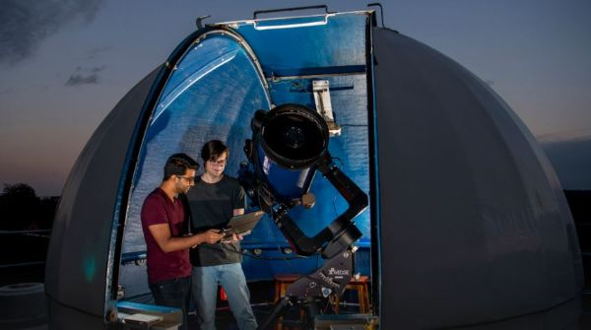

Calling all Science Students and Teachers interested in Balck Holes and the Aurora!
Please help us with our Research via our online Citizen Science activities:

Black Hole Hunters:
Learn about Black Hole research using the Superwasp Telescope and prepare to help us find Black Holes.
Click here for more information

Aurora Zoo:
Learn about the Northern Lights and Help us classify different types of Aurora.
Click here for more information



Southampton Theory Astrophysics and Gravity (STAG) Research Centre Online Masterclass for A-Level Physics Students
Monday 24th June 2024 12:45 - 4:00 pm
Meet the Scientists at the University of Southampton working at the cutting edge of Quantum Physics. By the end of this Masterclass, you will have learnt about the basic ideas of Quantum Mechanics including some of the peculiar consequences such as tunnelling. We will also introduce quantum computing which offers the possibility of faster computation and a quick way to simulate quantum systems in nature.
Online Timetable:
12.45pm – 12.55pm: Registration
12.55pm - 1.00pm: Welcome/Introduction by Professor Nick Evans
1.00pm – 1.50pm: “An Introduction to Quantum Mechanics” by Dr Elinor Twyeffort
1.50pm - 2.40pm: "Quantum computing: simulating the quantum world using quantum mechanics” by Dr Bipasha Charkraborty
2.40pm – 2.50pm: Break
2.50 - 3.30pm: A panel of our academics and students will introduce themselves and
their work and answer your questions on any area of our research.
3.30pm - 4.00pm Plenary and Evaluation
4.00pm - Finish
Technological Requirements: The event will be run via Blackboard Collaborate. Ideally each participant will need their own access to a computer with internet connection. We recommend using Chrome as your browser to ensure a good quality connection
For more information about STAG please click here
For further information about the Masterclass please click here or, contact PJ@soton.ac.uk



Take your career international: learn how businesses tackle the modern global landscape
Monday 15 April - 16:30 - 17:15
Join experts Dr. Yang Liu and Holly Street, along with Business students from the University of Southampton, as they delve into the world of International Business. You’ll learn what opportunities there are in international business, from the different careers and skills in the industry, to how our students have worked with international businesses on their course.
Book your place

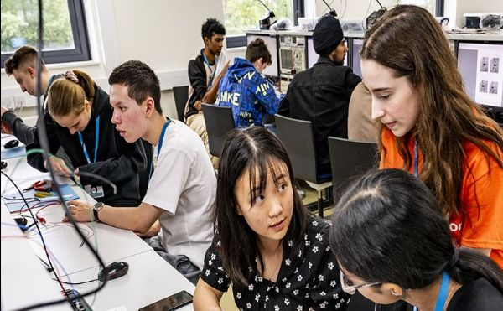

Biomedical Engineering / Electronics & Computer Science Taster Course
Enjoy a Summer of Technology!
The University of Southampton is proud to host the ECS Summer Taster Course - a great way to find out more about subjects at the cutting edge of technology, and to explore whether this sector is right for you.
If you love mathematics, technology, or science, this course will enable you to learn and apply new skills with like-minded students.
This one-week residential course will enable you to experience either Biomedical Engineering or Electronics and Computer Science. You will live life as a university student with a busy programme:
- Try your hand at real experiments in our state-of-the-art laboratories
- Learn about our teaching and research from our globally renowned lecturers
- Get to know current students and recent graduates
- Enjoy social events and meet fellow students
- Experience life on campus
- Meet leading employers at our annual careers fair
The University of Southampton has an outstanding reputation for Electronic Engineering, Computer Science, and Biomedical Engineering. We are a member of the prestigious Russel Group of research universities, and our degrees are ranked amongst the strongest in the UK.
£349 for this one-week residential experience (reduced rate and full bursaries available)
More Details & Apply

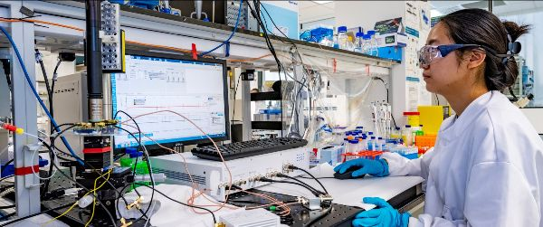

Replay the Webinar for Biomedical and Medical Engineering
On Monday 18 March, we hosted a webinar that introduced the world of Biomedical and Medical Engineering. A panel of academics and current students spoke about how technology is being used to help improve the quality of life for those with illness or injury, and the options for studying engineering for healthcare.
We welcomed over 70 guests to the session and had a great set of varied questions asked to our panel.
For those unable to make the session live you can now view the recording in your own time by clicking the button below.
Further information about the subject area can also be found here - Biomedical Engineering Campaign | University of Southampton
Watch the Recording



Textile Design collaborative projects with Occupational Therapy
Our Level 2 Textile Design students recently took part in a 4-week project to design and produce fabrics for educational sensory toys for children with specialist needs. For example, young children who are developing their fine motor skills, those with sensory processing disorders, children with neurodivergence or disabilities etc. Students had to carefully consider material, colour and finishing choices as well as safety aspects of their materials. This project was important for students to think of textiles outside the familiar fashion and interiors sectors, it also encouraged students to think about neurodiversity, inclusivity and wellbeing. The project was conducted with input from Occupational Therapy degree staff and students at the University of Southampton, including a visit by OT students to WSA during which students were able to share their projects and reflections.
The students will continue to collaborate up to a showcase in June. Our students gained experience through a question-and-answer session with OTs from ACE children’s occupational therapy centre and gave insight into the needs be considered.
The project resulted in huge range of designs and ideas from playmats to interactive puzzles.
Find Out More!



Change people’s lives with a career in Nursing
Student nurses at the University of Southampton share their stories, offering insight into becoming a nurse, making a difference to patient’s lives, and how they chose which field of nursing to pursue.
Watch Here

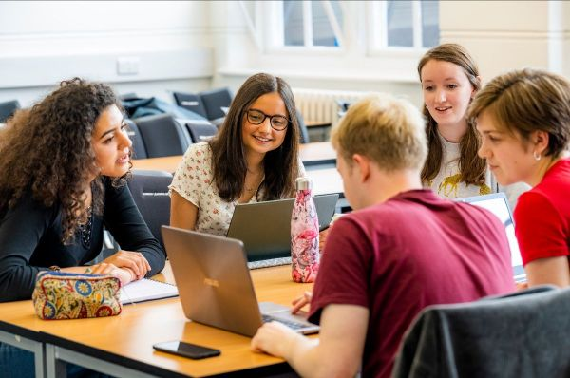

*NEW* BA Language, Culture and Communication
We would like to let you know about our new BA Language, Culture and Communication programme, which is part of the Languages, Cultures and Linguistics department at the University of Southampton.

This is an Interdisciplinary programme that offers a combination of modules in ethnography, cultural studies, sociolinguistics, and digital and non-digital communication. It explores key concepts underpinning the connection between language, culture and communication in global contexts.
This innovative programme is aimed at non-language specialists, with the option of starting 1 or 2 languages at ab initio level (from scratch): including French, German, Portuguese, Spanish, Chinese, Arabic and Italian. It is therefore ideal for students who did not have the option to continue with languages at A-Level but are interested in studying languages at university.
Career opportunities include working in creative arts, information technology, management, the mass media, social work, counselling, education, language teaching, and more!
More details about the programme can be found here and you can also watch the programme information video here.
If you have any questions or wish to know more, please, please do get in touch with us via email at AdmissionsUG.AH@southampton.ac.uk

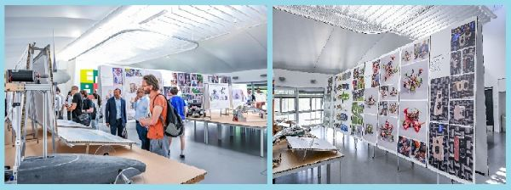

School of Engineering Design Show
Friday 14th June - 10:00 - 14:00
The School of Engineering’s Design Show gives school groups of all ages the opportunity to see STEM creativity and design in action. Our student show displays the best design projects from across mechanical, aeronautical, acoustical, astronautical, civil and maritime engineering. As part of the experience, we would like your students to vote for their favourite project to win an award. In addition to university students’ work, we are pleased to present an exhibition from our charity partners at Primary Engineer.
The show will open to school groups from 10am to 2pm on Friday 14 June and we recommend 90 minutes to look around the full show. We can also accommodate further school visits every Wednesday until the end of your school summer term if your group would prefer a later date. We would particularly welcome and encourage visits from students whose backgrounds are currently underrepresented in STEM subjects at university level.
To book your place, please email Sue Jenkins (School Operations Manager) at designshow@soton.ac.uk with details of your group.
Please see last year’s show website for a taster of what to expect: uosdesign.org/designshow2023/

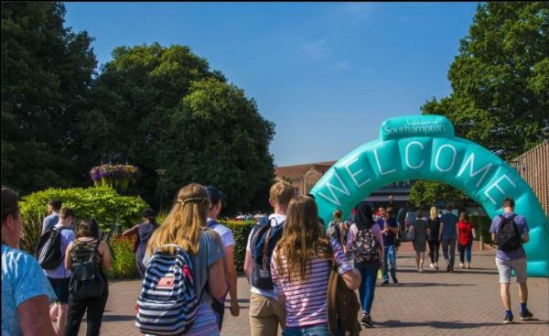

Our 2024 Open Days
Booking Opens in May!
Our undergraduate Open Days are your chance to explore our beautiful campuses and discover what it’s like to live and study with us.
Southampton Campuses
(Including Highfield, Boldrewood, National Oceanography Centre and Avenue)
Saturday 6 July
Sunday 7 July
Sunday 8 September
Saturday 5 October
Sunday 6 October
Winchester School of Art Campus
Saturday 15 June
Sunday 8 October
Wednesday 30 October
Saturday 16 November
There’s lots for you to discover at our Open Day. At this event you will have the opportunity to:
+ Visit subject facilities, studio spaces and the library
+ Hear from expert academics at your subject talk
+ Chat to current students about their experiences
+ Tour our accommodation to see where you could be living
+ Explore student support and careers at the student life hub
+ Discover our green spaces and social spaces
+ Explore our historic city
Register your Interest

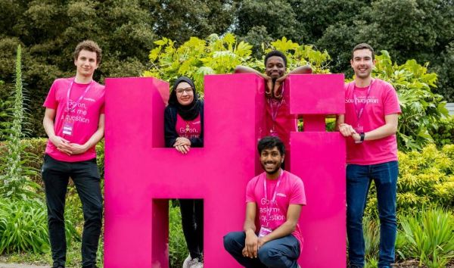

Widening Participation Travel Bursary
Invitations are now being sent to offer holders for our subject visit days taking place through February - April 2024.
We understand that travel costs can be a barrier when you are invited to attend a University event. We would therefore like to offer a travel bursary of up to £100 to help cover these costs to eligible students.
Please forward on to your Year 13 University of Southampton Offer-Holder students who would have received an invite to one of these visit days to complete the application form.
Eligible students will be reimbursed after attending the event.
Terms and Conditions and application can be found below.

Travel Bursary

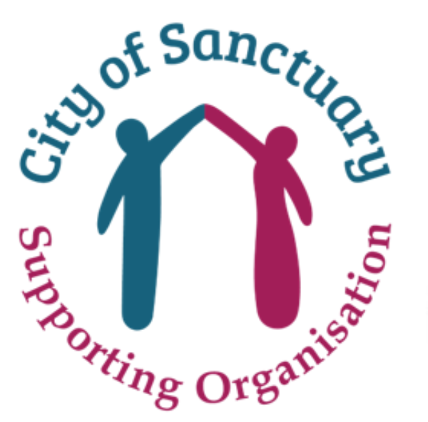

Sanctuary Scholarships
The Sanctuary Scholarship at the University of Southampton is now open for applicants who have already applied, and are holding an offer from us.
The closing deadline is 7th June 2024.
This scholarship is available for new undergraduate (UG) students, starting September 2024 who are seeking sanctuary in the UK.
The University of Southampton will:
- cover 100% of tuition fee costs for each year of study (3 years)
- provide a bursary for each year of study to help with additional study costs (this is flexible given individual circumstances)
- provide a welcome pack
- support with university accommodation
The University of Southampton, like many other institutions, offers Sanctuary Scholarships to support displaced or refugee students. These scholarships are part of the university's commitment to providing access to education for individuals who have been forced to flee their home countries due to conflict, persecution, or other crises.
The Sanctuary Scholarships aim to remove financial barriers that may prevent displaced individuals from pursuing higher education.
If you or your students would like to know more please visit our website for more information and terms and conditions, or contact: sanctuary@soton.ac.uk
More Information

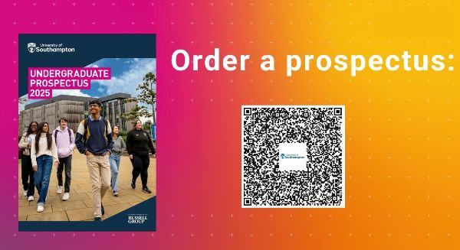

2025 Undergraduate Prospectus
Explore the courses and programmes we offer and find out more about the University by ordering a copy of our prospectus (available either by immediate download or postal copy)

Please do share with your students!
Order a Prospectus

 |  |  |  |  |  |  |  | 

liaison@southampton.ac.uk

University of Southampton
All Rights Reserved
Privacy policy

