Year 11
Study Habits of Successful Students


1. Revision tips
2. Study Skills
3. Timetables

Name: _____________________________
Mentor group: ____________


REVISION TIPS
Tip 1 – Plan for your revision. It is important to have a structured approach to your revision because it means you can be sure of covering everything you need in the time available. You will look at how to create a revision timetable in a separate mentor session.
Tip 2 – Create the right environment. When you revise at home use the following tips for creating the right environment: Create a proper study area with no distractions. Most people revise most effectively in a quiet environment however playing music at certain times might motivate and inspire you.
Tip 3 – Effective revision is based on discipline, organisation and staying motivated. This will help you stay in control. See the medium and long term goals of exam success. Don’t put it off, face up to it and give yourself little short term targets and reward yourself. This will reduce the inevitable bouts guilt, panic and the inevitable, “There’s not enough time. I wish I’d started my revision sooner.” The only solution is good planning and time management. Your lessons are the journey and your revision and exams are the final destination – enjoy both.
Tip 4 - Before you can even plan what you need to revise it is important to check that you have everything you need. Your notes need to be: ¬ Arranged systematically ¬ In a separate file for each subject ¬ Labelled clearly with dividers What to Revise.
Tip 5 - Write down carefully what your teachers tell you to revise. If they tell you to revise anything, ask them to suggest what is most important. Decide what you know least about, or find difficult. Do that first. Make sure you don’t give more time to your favourite subjects whilst neglecting those you hate.
LEARNING HOW TO STUDY BETTER 
Motivating yourself to revise is a tough thing to do, so we hope that by reading through this study skills booklet you will pick up some tips which will help you study in a more effective way and increase the amount you learn. Working through this booklet should enable you to:
1. Draw up a revision timetable for your study day
2. Draw up a schedule for your revision sessions in school
3. Try out different study techniques at home
4. Organise yourself with the right resources
5. Produce a mind map (spider gram) to help with summarising notes
6. Use your memory more effectively
7. Create different mnemonics to help you learn
8. .Check out new websites which help you revise. Remember also that everyone is on your side. If you need help with studying.
9. Help you cope with the pressure, the right food to eat, effective hydration, and coping with the pressure of exams.
10. Make you aware of getting balance and the importance of down time, seeing friends and keeping active.
Remember also that everyone is on your side. If you need help with studying, ask a teacher, ask your friends or your parents.
How long should I study for?
According to The Student Room,
“Students revise 15 to 20 hours per week for their exams, which might sound a lot until you break it down. You've probably worked it out for yourself, but the recommended time equates to 2 to 3 hours a day (broken down into 30-45 minute segments)”
Study Hints and Short Cuts
1. Attend revision classes.
2. Schedule regular study periods.
3. Be realistic with what you hope to achieve in each study session.
4. Establish a regular study area at home eg desk, quiet area
5. Study short and often
6. Start your study sessions on time- be accountable.
7. Study when you are wide awake (early mornings maybe quotes, formulas or study cards.)
8. Set a specific goal for each subject you study – “by the end of this study session, I hope to have learnt……………………in Geography”.
9. Study your most difficult subjects first.
10. Make summary notes on what you have learnt LOOK, SA,Y COVER, WRITE CHECK.
11. Use diagrams and mind maps to help with learning.
12. Highlight key words using highlighter pens and post it notes.
13. Take regular breaks and use them effectively- down time to recharge.
14. Vary your work e.g. make notes, draw diagrams, read, problem solve..….
15. Reward yourself!
16. Balance your time carefully between home, school and social outings.
17. Produce revision timetable organised in advance and displayed for everyone to see.
18. Keep a stock of post-it notes, highlighter pens, and revision cards at home.
19. Get your parents involved with your timetables and revision- they will support.
20. There will be times of doubt – but see the medium and long term rewards of success. Great exam results in year 10 and 11. Successful post 16 studies/apprenticeship – the job or career of your choice.


1. Make the most of your resources
2. Preparing for exams is just like training for a sport, skills can be improved with practice.
3. Review and correct your past mistakes.
4. Study in a quiet area with good lighting and ventilation.
5. Study for a short periods of time with frequent breaks.
6. Reduce stress by eating well, being organised, exercise regularly, learning to relax, avoiding arrangements and talking about problems.
Your Study Area Should be
- Light, bright, no phone, comfortable, Pick one place, and like it, Recreate your environment, Get comfortable—but not too comfortable, Look for natural light, Don't look into the light, Swap music for ambient noise, Buy some plants, Turn off your phone. Total focus


1. Quizzing. Good old fashioned quizzing is an ideal way for to test which is proven to be a robust revision strategy, so that you can calibrate your knowledge and remember key points. There are various types of quizzes, of course, such as short answer quizzing, multiple choice or a hybrid of the two, with different question types suiting different purposes.
2. Flashcards. Flashcards are a very familiar tool used by students. Crucially, however, too many of you fail to use them for effective self-testing – (Research states only 30% students at GCSE use flashcards ). You need to train yourself to design, or find, effective ways of developing flashcards. Keep some with you.
3. Graphic organisers. You need to be active in revision, not just reading your notes and doing some colouring in with a rainbow of highlighters. Graphic organisers are a handy vehicle to get you reconstructing your revision topics, making meaningful links and connections (in cognitive science, this is labelled the ‘generation effect‘).
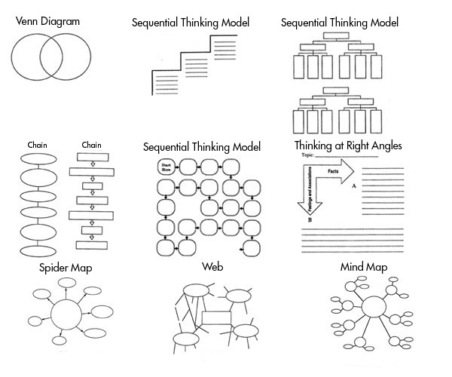
4. Cornell note-taking. Another strategy that uses the ‘generation effect‘ is the well-known note-taking approach: the Cornell method. Named after the US university, this strategy gets you thinking met cognitively, asking questions, noting key terms, and summarizing the content being revised.
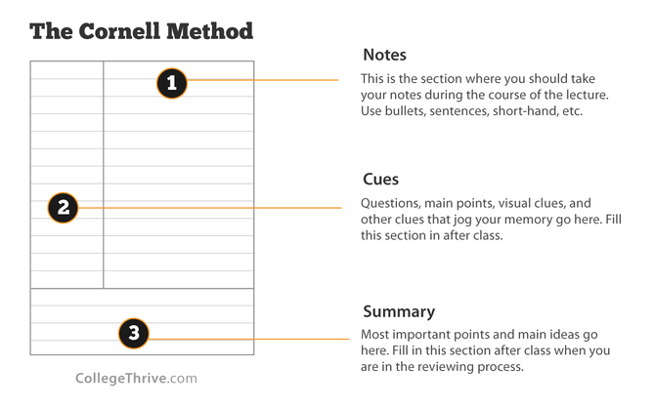
5. Exam wrappers. This helpful feedback strategy, labelled ‘exam wrappers‘ because they wrap around information on how you have revised, offers important information for the teacher to help diagnose how effective, or extensive (or not), revision has proven. Also, it can prove a good way to help puncture student over-confidence in their revision.
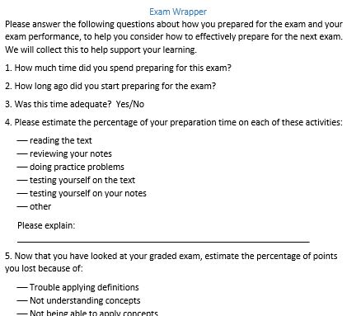
6. ‘Just a minute’. Just a Minute’ takes the classic radio game and adapts it to almost any topic, text, or examination revision term. Put simply, you have to talk for a minute on the given term/topic – no pauses, no hesitations. Slips or repetitions or micro pauses lose a ‘life’ – three strikes and you’re out. This strategy harnesses the ‘self explanation effect‘. In short, if you can elaborate on a topic and explain it well, you have retrieved it from memory – a good revision act – as well as likely consolidating it too.
7. ‘Prepare to teach’. Similar to ‘Just a Minute‘, the ‘Prepare to teach‘ strategy involves the common idea of you teaching a peer/parent a topic/term from your revision. Once more, it gets you to elaborate on your knowledge. Even expecting to teach appears to have a positive impact on students learning material, so this seemingly inconsequential tweak can have very beneficial effects.
8. ‘Select, elect’. Another revision strategy that gets you thinking hard about their revision is ‘Select, Elect‘. In simple terms, you ‘select’ the most important facts, ideas, concepts, or terms, from a given revision topic. You then ‘elect’ what you deem the most significant knowledge or idea/concept that you need to understand for your exam. This will ensure that you are actively engaged with your revision material, whilst being metacognitive about what are the key points that you need to remember.
9. Topic ranking. Remember you are sometimes not the best judge of your own revision and how effective it may or not be. Topic ranking is where you rank your own knowledge of your topics being revised, they deploy the important metacognitive strategy of evaluating their learning. It still helps you to better calibrate your revision and monitor your ongoing progress.
10. Past questions. You need to practice examination questions, over and over, well spaced over time. The effect of exploring worked examples or exam answers, as well as writing their own, helps students process, practice and refine their revision to meet the parameters of exam success.

Mnemonics Mnemonics are one way of remembering a list. A mnemonic makes a word or a phrase from a set of letters based on the list. All you have to do is remember that first word or phrase and rest should come flooding back.
A mnemonic for improving your listening skills: L= Look ahead I = ideas S=Signs & Symbols T= Take part E= Explore N=Notes Another very common mnemonic is the one to help you remember the colours of the rainbow.
Richard of York gained battles in vain What are the colours of the rainbow: …………………………………………….
https://www.youtube.com/watch?v=VoYOb2sPnqA - Mnemonics
Make up examples of mnemonics which could help learn a specific piece of theory from 3 subjects.

Make up examples of mnemonics which could help learn a specific piece of theory from 3 subjects.

Mind Mapping
Revising the topics If you don’t understand what you have just read in your book, try
1. Reading it aloud
2. Checking that you have copied the notes correctly
3. Highlighting key words
4. Writing it out in your own words
5. Making a mind map
6. Converting the notes into a picture or cartoon strip
7. Discuss the problem with a friend or teacher
Mind mapping Techniques For Students. - https://www.youtube.com/watch?v=AIQeWf3gIsQ – 3.05

https://www.youtube.com/watch?v=MJJeT22UpZA - How to Get Straight A's! | Mind Mapping – 4.35

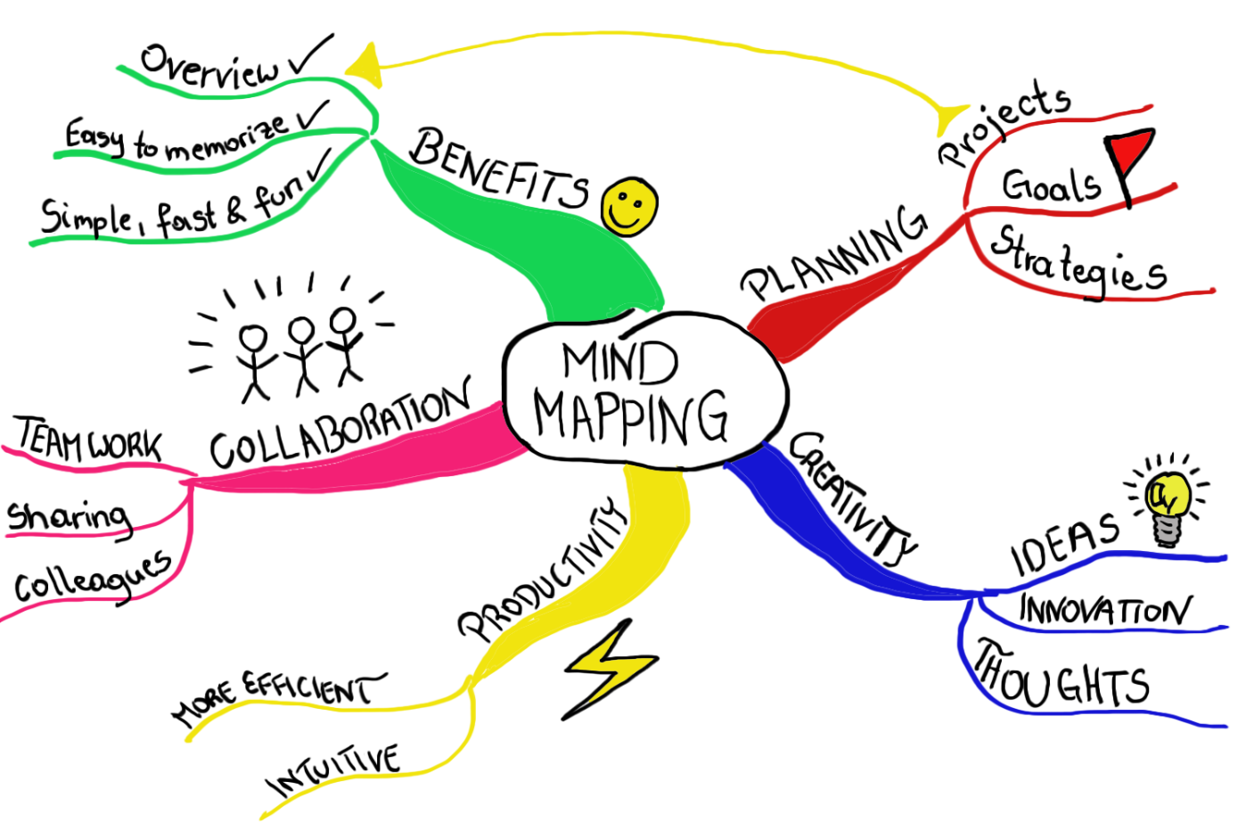

Choose a subject and topic to create a mind map

2 New Ways to Use Sticky Notes // 2 Minute Study Tips.
https://www.youtube.com/watch?v=cDYETOzFyYw -2.36

Use some post it notes for a topic within in a lesson. Using the video clip above state how you will apply it to your revision/learning.

Growth Mind Set
Working towards the factors on the right
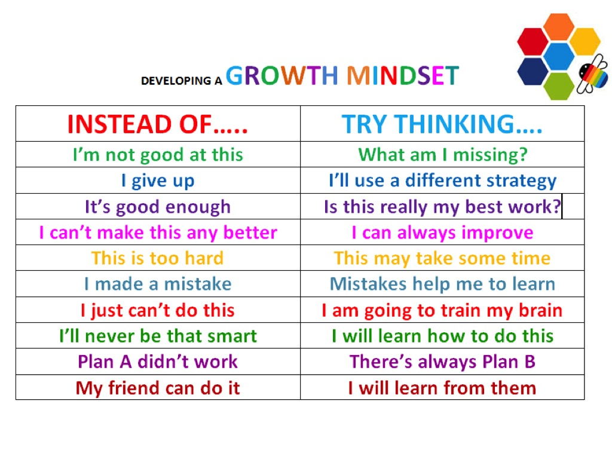
Strategies for Growth Mind Set that will support me with preparing for exams
- A

- B

- C

- D

Revision Tips
Memory Caring for your brain
1. Get enough sleep and exercise. Oxygen is food for your brain
2. Eat right – practice choosing food with good nutrition
3. Use it! Condition your brain by doing puzzles and games, reading, solving math problems, storytelling.
4. Be motivated to learn – you must have a reason to remember
5. Think positive! Use positive self-talk. This helps your attitude and openness to learning.
https://www.youtube.com/watch?v=NHr8NI337SA - Eating to Remember: Memory-Boosting Brain Food – 2.15
Memory Tips
1. Study in a quiet place in the house
2. Recite and repeat. Say it out loud! LOOK SAY COVER WRITE CHECK. Record your own voice reading out notes
3. Spend more time on your weakest subjects, vocabulary, mathematics, spelling
4. Teach it to someone else
5. Use mnemonics to help you learn eg Planets
Mercury Venus Earth Mars Jupiter Saturn Uranus Neptune Pluto My Very Earthly Mother Just Served Us Nine Pizzas.
Understand How Your Memory Works
Some of us are better at remembering things than others. Here is a trick that should help. If you learn something new, in general it will already start fading in your mind after a few hours, (unless it is particularly exciting). However, if you revise again in the next few hours, it will take About 24 hours before it starts to fade. Revise it in the 24hr period and it will last for four days, then one and a half weeks, then one month and so on. By setting your revision schedule to make the most of this (learning something, revise It again after few hours, revise it again in the next few days, and so on) you will be using The way your memory works to an advantage!!!

Put aside specific hours in the day For revision If you set aside the hours in the day you are going to revise, and let everyone know what these are, you can make sure you are not disturbed. You can then get into a ‘revision package’- where your mind expects to be revising and is there-fore more receptive to the material.
The Learning pyramid below highlights the key forms of retaining information and the most effective ways for learning. So look to focus on teaching others and practice your revision by doing as well as discussing with peers and family members,

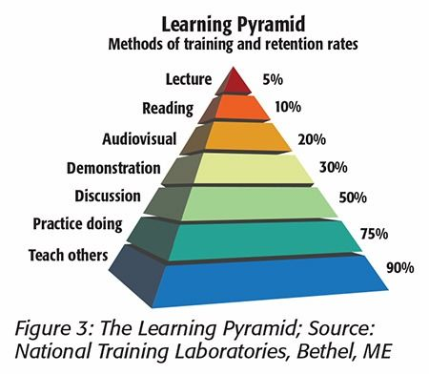

Healthy Hydration
5 Amazing Ways Drinking Water Affects Your Brain: https://www.youtube.com/watch?v=hL-iMwqgs4Q – 3.50

Choose 2-3 ways that you can develop your understanding of effective hydration to support your studies:

A

B

How to Improve Concentration and Focus: 7 Tips
- Be conscious and intentional. I keep coming back to “consciousness” as the cornerstone of most effective learning habits. ...
- Set clear goals – and victories. I've lamented my own lack of goal setting before. ...
- Be consistent. ...
- Avoid or remove distractions. ...
- Set time limits and allow for breaks. ...
- Take care of mind and body. ...
- Practice.

Choose 2-3 of the above to focus on over the next few weeks. To apply in your lessons and revision programme.

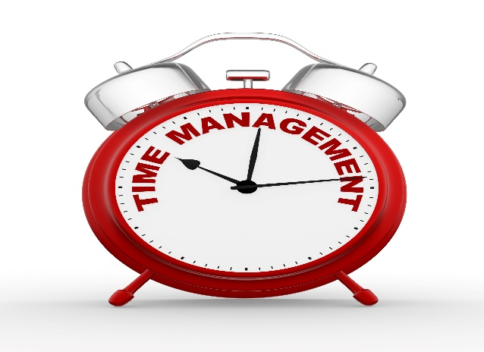
The ABC daily to-do’s
1. Write out your daily to-do list the night before. Everything you want to accomplish for next day.
2. Label each task A, B and C
3. A’s on your list are those things that you are most important – homework due in other jobs which need to be completed
4. B’s on your list are important, but less so than your A’s someday! These tasks are important but not urgent
5. C’s do not require immediate attention – C priorities are often small, easy jobs
https://www.youtube.com/watch?v=JGr46kYMEQQ - Study Skills – Managing your time
https://www.youtube.com/watch?v=rUO8Qvcs7cY - Student Success - Time Management
Write down 2 time management skills that will help you with your studies/exam revision

An Important skill is learning how to prioritise! Treat your revision schedule like this.
1 .Plan Ahead
Before you do any work, sit down and plan what you are going to do between now and the exams. It is often a good idea to revise the areas you find most difficult first – get them out of the way and build your confidence in the subject.
Creating a timetable is always a very useful as your time is now precious, so make it work for you Starting early will give you the stress free ‘little and often’ approach. In other words planning

Make summary notes
Gather all your material for the topic area and reduce them into brief clear
notes. Then summarise those, and then again and again until you only
need a few keywords to remind you of the whole topic!!
You can carry around a sheet with all the keywords wherever you go…….

An effective way to make sure
You remember certain things is
To invent mnemonics. For example
Never Eat Shredded Wheat- North East South West

Revision Time tables.
You should have already plotted a practice revision timetable.
This should include your lessons.
After school sessions.
Activities away from school and down time.
Any other key points?

Cornell Note Taking
https://www.youtube.com/watch?v=WtW9IyE04OQ - How to take Cornell notes. 5.26
Choose 1 subject/topic and write down how you can apply this to your learning/revision

Flash cards - How to Study Effectively with Flash Cards - College Info Geek
https://www.youtube.com/watch?v=mzCEJVtED0U – 8.43
Choose 1 subject/topic and write down how you can apply this to your learning/revision

And Finally your future success will be based on
- It’s important to remember that an examination is a test of learning, not memory.
- Examiners want to see evidence that you have drawn on your knowledge to develop a reasoned argument, rather than replicate course notes and textbook facts. Revision should be a process of consolidating understanding rather than cramming as much information as possible before the morning of the exam.
- Study Skills Where to study: Creating good conditions to study can help you make the most of the time you spend revising. Make sure your desk is well lit Keep background noise to a minimum Avoid studying in an area where there will be distractions
- How to study: There is no ‘right way’ to revise, as long as the method you choose enables you to gain a solid grasp of key facts and consolidate your knowledge. Some students are happy to read their classroom notes from start to finish.
- Others prefer to simplify the information as much as possible, turning everything into skeleton notes, diagrams or mnemonics. In practice, most students find that mixing techniques suits the varied nature of the subjects being revised, and provides essential variety when studying.
- Turn your notes into revision tools; Write ideas and facts on to cards to use as ‘prompts’. Create memory aids such as diagrams or mnemonics (e.g. initial letters to make a word you need to remember or SMART objectives: Specific; Measureable; Achievable; Realistic; Targets). These will help you remember key facts
- Write facts/notes out and display these around the house where you will see them • Record yourself reading notes to listen to.
- Study with a friend and test each other’s knowledge, but remember you are meeting to revise rather than to chat!
- Work through past question papers – and use a watch or kitchen/egg timer to time them so that you can practise timing your answers.
- Choose study and revision guides sensibly. It’s not hard to find help with revision – as well as established published revision guides, there are hundreds of websites offering help and advice. The problem is not how to find such help, but how to judge what suits your needs best.
- Save valuable time and get recommendations from your teachers.
- Attend any revision classes that your teachers may be running at school and get their advice on revision methods.
- Look after yourself – Sometimes revision can become a competition – who stayed up latest, who worked longest, who’s worrying the most. But the more tired you are less efficiently you’ll work. You need to rest as well as study, eat well, drink lots of water and make sure you pace yourself. Don’t rush, and equally don’t over-revise by doing too much too soon
Revision Plan
- The top tip for successful revision is to make a plan; otherwise it is easy to waste your precious revision time. We recommend that you start your revision at least two months before your year 10 exams begin.
- List all your exam subjects and the amount of time you think you will need for each one. It is unlikely that the amounts will be equal. Many people find it advisable to allocate more time to the subject or topics they find the most difficult.
- Draw up a revision plan for each week. Don’t forget to work in some leisure / relaxation time too!
- Use revision checklists or Syllabuses for each subject as a starting point. Look at what you need to know and try to identify any gaps in your knowledge. (A good way of doing this is to look at the results of past papers or tests you have worked through).
- Divide your time for each subject into topics based on the units in the revision checklist or syllabus, and make sure you allow enough time for each one.
- Plan your time carefully, assigning more time to subjects and topics you find difficult
Revise often; try and do a little every day
Plan in time off, including time for activities which can be done out in the fresh air. Take a 5 or 10 minute break every hour and do some stretching exercises, go for a short walk or make a drink
- You may find it helpful to change from one subject to another at ‘break ’time, for example doing one or two sessions of maths and then changing to Geography, or alternating a favourite subject with a more difficult one. It helps to build in some variety.
- Write up your plan and display it somewhere visible (maybe on your bedroom wall, or above your desk wherever that may be). Adjust your timetable if necessary and try to focus on your weakest topics and subjects.
Don’t panic; think about what you can achieve, not what you can’t. Positive thinking is important!
- You have lots of time to improve before your next exam so allow yourself some fun-time each day to relax. Eat sensibly – your brain cells need energy to function well. Make sure you drink plenty of water to avoid becoming dehydrated. Dehydration makes you tired and reduces concentration. •
- Exam tips – sitting the exam Be prepared; find out what is involved in each of the examinations that you are going to sit. Organise yourself the night before and get plenty of sleep. Check you have the correct equipment with you before you leave the house (pens, pencils, calculators_

https://www.youtube.com/watch?v=t4BdlqQ5j0k – Exam revision tips- part 1
https://www.youtube.com/watch?v=t4BdlqQ5j0k – Exam revision tips – part 2
https://www.youtube.com/watch?v=HjIoA_TI4Nw – GCSE Revision tips
Any final Key Notes

