Spirited Arts Competition
This year the RS department are delighted with the outstanding entries of the Spirited Arts Competition. This competition gave out students to create a piece of visual art using drawing, painting, video, sculpture or other media to represent a particular religious message or theme. This year, the competition sought to combine the religious concept of “Where is God?” with art, enabling students to express creatively their reflections on this question. In addition, they also submitted a written piece to explain how their work linked to the theme.
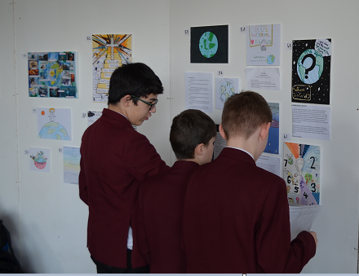
With more than 100 submissions from across the school, they were showcased in the chapel in an engaging exhibition to display the art. This allowed students to view each other’s work and then vote on their favourite. Students were given the chance to analyse the art whilst comparing it to what they had been learning in class, and were given the opportunity to make synoptic links between the artistic thoughts of others with their current and previous learning.
The winners were announced during assemblies, prizes awarded to the winners. Well done to all entries and congratulations again to:
- Ellie Crain (Yr. 7) – Head teachers Award
- Emily Dawson ( Yr. 7) – ALT Award
- Bidisha Choudhury ( Yr. 8 ) – RS Teachers award
The winning entries have been submitted to the National Association of RE competition where the winners will be selected in August.
RS teacher’s award
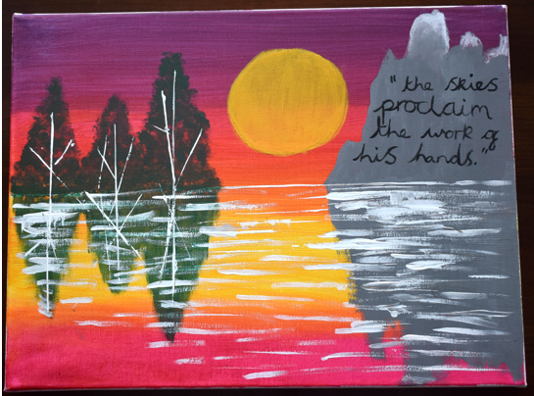
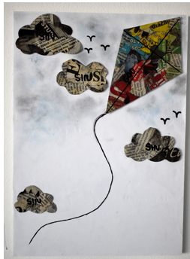
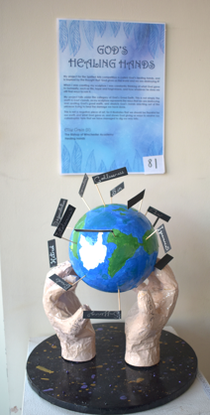
ALT award
Head teacher’s award

