Knowledge Organisers

Knowledge Organisers can be found on the school website under **Curriculum** and **Knowledge Organisers** (see below)

<https://www.tbowa.org/curriculum/knowledge-organisers>

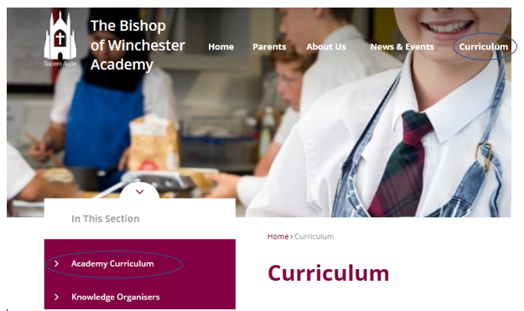

**KO Collection**

You can either print, use the digital version or collect a hard copy of the KO booklets for your child for this half term. The booklets required for each year group are outlined below:

* Year 7 – Core and Foundation (2 separate booklets)
* Year 8 – Core and Foundation (2 separate booklets)
* Year 9 - Core and Foundation (2 separate booklets)
* Year 10 – Core (1 booklet)
* Year 11 – Core (1 booklet)

**Homework Grids**

In the front of each booklet you will find the homework grid for that half term. This details what subject and what lines should be studied on a particular evening. They will need to identify the correct day, turn to the page for the subject specified on that night and use ‘look, cover, write, check’ to revise the lines specified. The homework is due to start on Monday 11th January which is reflected in the homework grid.

**Quizlet**

The Knowledge Organisers for L1 have also all been uploaded to the **Quizlet** website which students have seen in assemblies and had the opportunity to us. Please encourage your child to use these amazing resources to further support them with their Knowledge Organiser homework retention. All the KOs on Quizlet can be found under this link: <https://quizlet.com/BishopOfWinchester> . They are named according to subject, year group and week (matching the homework grid). For example, ‘TBOWA Y7 Spanish L1 Set 1’ will match the lines that Y7 students be revising for Spanish during week 1 of the homework timetable. Students will need to use the search bar to find the specific Quizlet set they are looking for.

Thank you for your support in ensuring that homework routines and standards are maintained so that your child can make as much progress as possible.